Dear [Name],

I’m writing you today with an opportunity to invest in the future of [Organization] and in my ability to create change, as its leader.

I am requesting support to participate in the National Arts Strategies (NAS) Chief Executive Program. This program brings together 50 leaders of top arts and culture organizations from around the world. Beginning in the fall of 2019 and running through the spring of 2020, this diverse group will learn cutting-edge tools from faculty at Harvard Business School and other leading academic institutions as they tackle the most pressing issues cultural organizations face today.

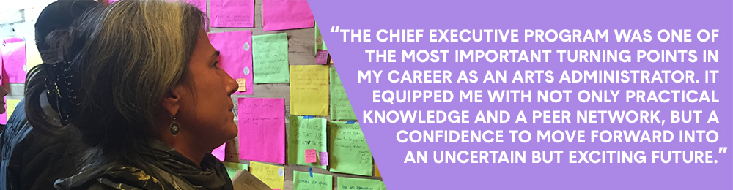

The program includes two in-person convenings, one-on-one sessions with an accredited leadership coach, and ongoing collaboration opportunities with a powerful global network.

Since 2011, NAS has trained over 250 leaders through its Chief Executive Program. Alumni of the program have attributed major accomplishments – including new organizational initiatives, partnerships and increased revenue – to their participation in the program. [Include the following sentence if applicable] Leaders in [Discipline/Community] such as [Name of alumni this donor might know] are alumni and they encouraged me to apply.

Participating in this program will enable me to be a more effective leader of [Organization]. Given our current goals of [X], this is the right time for me to gather more tools and gain a supportive network for creating change.

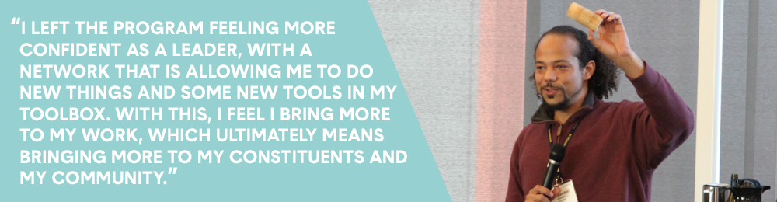

The value of this program is more than $20,000. NAS has been able to subsidize the cost to participants through grants, and participants are asked to contribute their part. The pricing for the program is by organizational budget size, and our level is set at [$X, as per table on website]. I am asking for your support in the amount of [$X].

Thank you for your support of our organization and our leadership sustainability. Please feel free to contact me with any questions.

